

**EMS Failed Trades Email Drafting**



|  |  |
| --- | --- |
| Project | EMS Failed Trades Email Drafting |
| Company | eClerx Services Ltd. |
| Prepared by | Vaibhav Chavan/Aditee Kuber |

This document is copyright protected in content, presentation, and intellectual origin, except where noted otherwise. You may not modify, remove, augment, add to, publish, transmit, participate in the transfer or sale of, create derivative works from, or in any way exploit any of the elements of this document, in whole or in part without prior written permission from eClerx Services Ltd. © 2010‑2011.

**Table of Contents**

1. Change Request Form 3

1.1. Request Details 3

1.2. Change Description 3

1.3. Business Need (if any) 3

1.4. Additional Comments 3

2. Revision History 6

3. Template Revision 7

# Change Request Form

## Request Details

|  |  |
| --- | --- |
| **Program** | METEOR |
| **Process** | EMS Failed Trades |
| **Initiator** | Vaibhav Chavan |
| **Date** | 26-July-2017 |
| **Tool** | EMS, Excel, Outlook |
| **Req ID** | -NA- |

## Change Description

Team currently drafts emails manually and sends out to respective PBs for settlement confirmation. An email drafting macro needs to be implemented which can draft all emails automatically in specific format for different scenarios.

## Business Need (if any)

Macro would help team to maintain quality and timelines , we can save some bandwidth as well which can be utilized for other activities.

## Additional Comments

1. Email drafting Macro should capture below details automatically.

* Macro should have functionality to capture PB-wise trade details automatically which are extracted from EMS.(Excel sheet)
* It should capture Prime Broker contact details automatically.
* Cc: Operations-asia [Operations-asia@mlp.com](mailto:Operations-asia@mlp.com), eClerx-asiaops [eClerx-asiaops@mlp.com](mailto:eClerx-asiaops@mlp.com)
* Subject : PB name- Failed trades

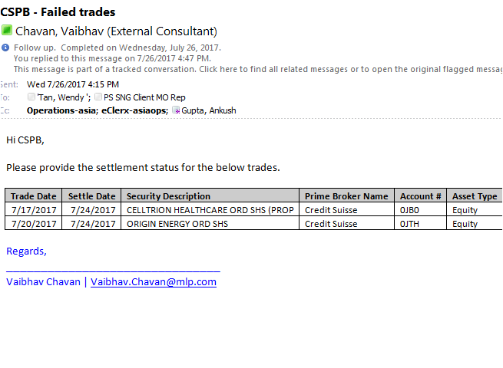

1. Macro should have functionality to draft emails based on below scenarios.

**Scenario 1:-** Settlement status

* + Send an email to respective Prime Brokers asking for Settlement status.
  + While sending email, include trade details columns from ’Trade Date’ to ‘Counterparty Name’.
  + Add broker’s contact list and copy [Operations-asia@mlp.com](mailto:Operations-asia@mlp.com), [eClerx-asiaops@mlp.com](mailto:eClerx-asiaops@mlp.com) as well.

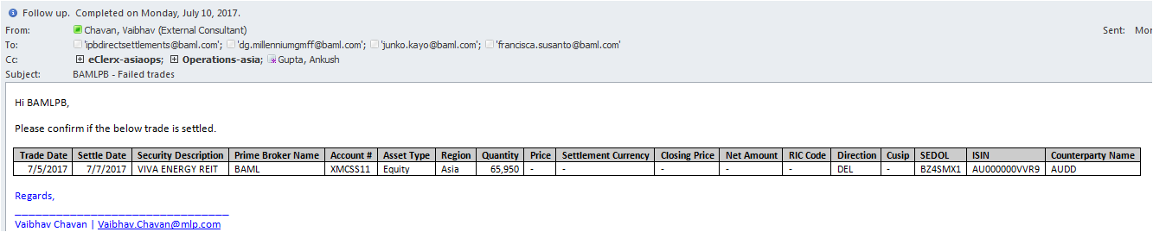

* + Once response received from PB, update comments in EMS.
  + Again extract the updated data from EMS by “Export to Excel”, highlight the ‘comments’ column and save the file.
  + Prepare an EOD email and attach saved failing trades report along with latest response email received from PBs.
  + The EOD report should be sent to-
* To : Su, Juanni [Juanni.Su@mlp.com](mailto:Juanni.Su@mlp.com)
* Cc: eClerx_Managers [eClerx_Managers@mlp.com](mailto:eClerx_Managers@mlp.com); eClerx-asiaops eClerx-asiaops@mlp.com; Fails fails@mlp.com>; Operations-asia Operations-asia@mlp.com;
  + Also attach Failing Trades Tracker maintained by eClerx.

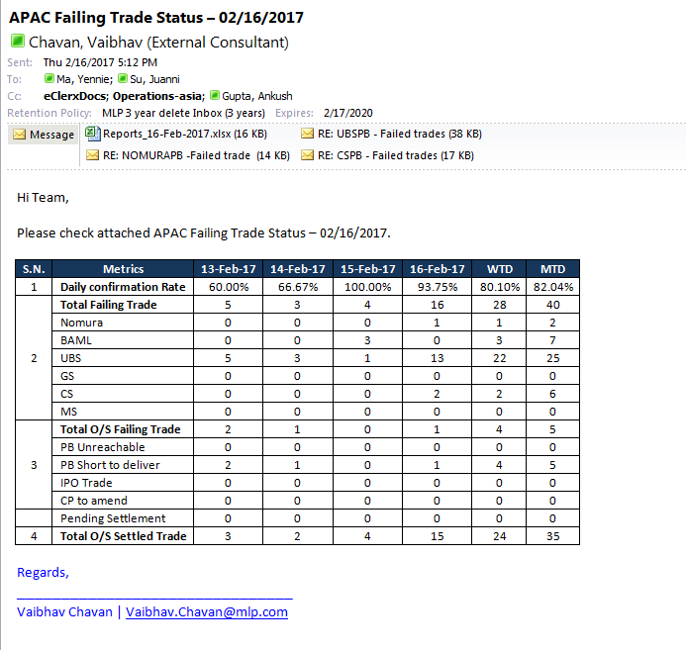

**Scenarios 2:-** Previous pending trades.

* For previous day pending trades we have to reply on previous chain email adding new trades separately (If any)

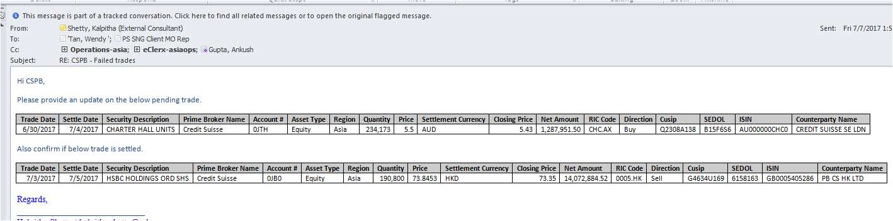

# Revision History

|  |  |  |  |
| --- | --- | --- | --- |
| Version | Date | Changed by | Change Summary |
| V 1.0 | July,26 2017 | Vaibhav Chavan | * Creation |
| V1.1 | October, 31 2017 | Aditee Kuber | * Updated |
|  |  |  |  |

# Template Revision